 ghumo.com

Make the World Your Spinning Top

Submitted by:

Team Name:

Double Trouble

Team Members:

Priyanshu Sinha

Saumya Joshi

LOGO:



The logo has been designed as a spinning top and it comprises of all the colors the earth is made up of. The logo symbolizes that through our site you can make the world a spinning top as you would be able to travel anywhere around the world conveniently by making all the reservations online, using our site ghumo.com.

PROJECT DESCRIPTION:

The project aims at creating an online booking portal which helps the user to plan trips very easily. Everything that a user may desire can be found just a few clicks away. Be it a luxurious hotel or budget rooms, domestic flights, trains, buses, cabs, we offer it all.

SPECIAL FEATURES:

* We have special privileges for our registered customers. We offer them an online wallet linked with our site which makes it easy for them to pay for their bookings.
* We give an option to users to connect with us via facebook or google plus and have a quick access to the special offers we provide to our registered customers.
* We have a loan facility which enables a registered user to confirm their booking even though they might borrow some or all of the amount from the site. This amount borrowed has to be paid 10 days before the travel date failing which the booking shall be cancelled.(This facility is not valid for bookings made 10 or less days before the date of journey.)
* We offer cab service with your hotel and flight bookings so you are always on time at your destination. We also provide pick-up services from the airports and railway station.
* We give reward points to our registered users on every booking. We also offer guaranteed cashback and discounts.
* We offer our customers to book hotels with their bus bookings. This makes their trip easy as well as a little easy on their pockets.
* We offer our pages on facebook and instagram for our customers so they can remain connected with us and know about all our special offers.
* We have tried to create our own dummy payment gateway so that it is easier for the user to make online payments. Users can also use e-wallets such as paytm, mobikwik for making payment.
* We have provided the user the opportunity to join our venture and expand their business by registering their services with us. We help their business grow and they help us in promoting our site.

PROJECT WORKING:

* For the proper functioning of the project, you need to install Xampp server on your machine and get the files(ghumo.com) pasted in php root directory (preferably C:\xampp\htdocs).

We have provided the setup of Xampp server along with our project.

* Copy and paste this URL in the address bar:

**http://localhost/ghumo.com/Pages/home.php**

* You will see this window:

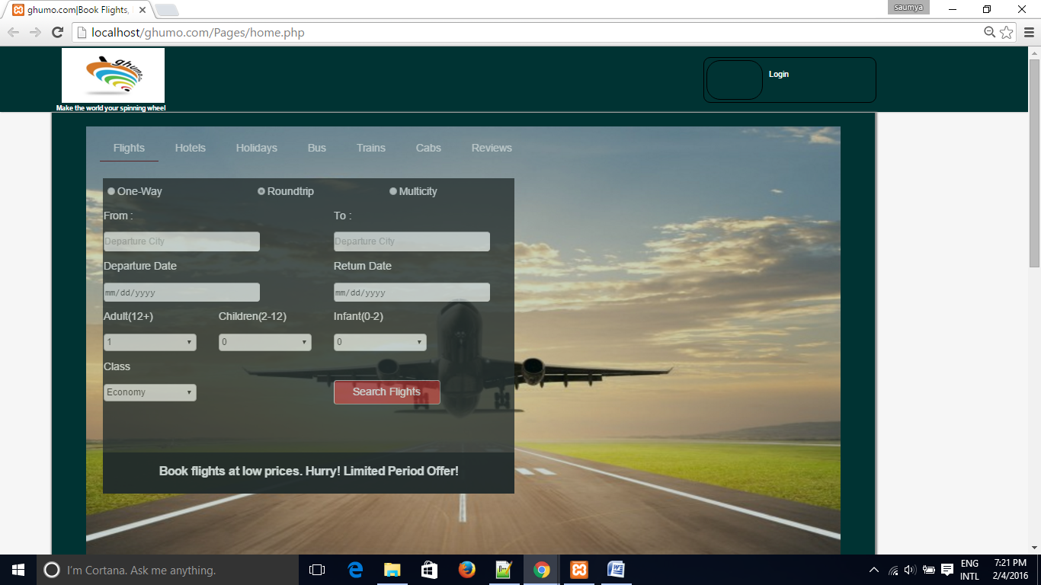

* Click on login to use the site as a registered user. You will be asked for your username and password. Enter the details and access your account.

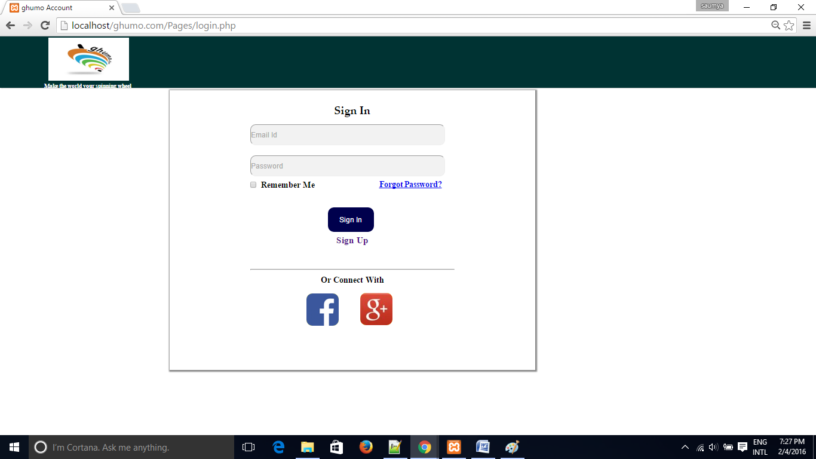

* If you do not have an account you can create an account by clicking on 'Sign Up'.

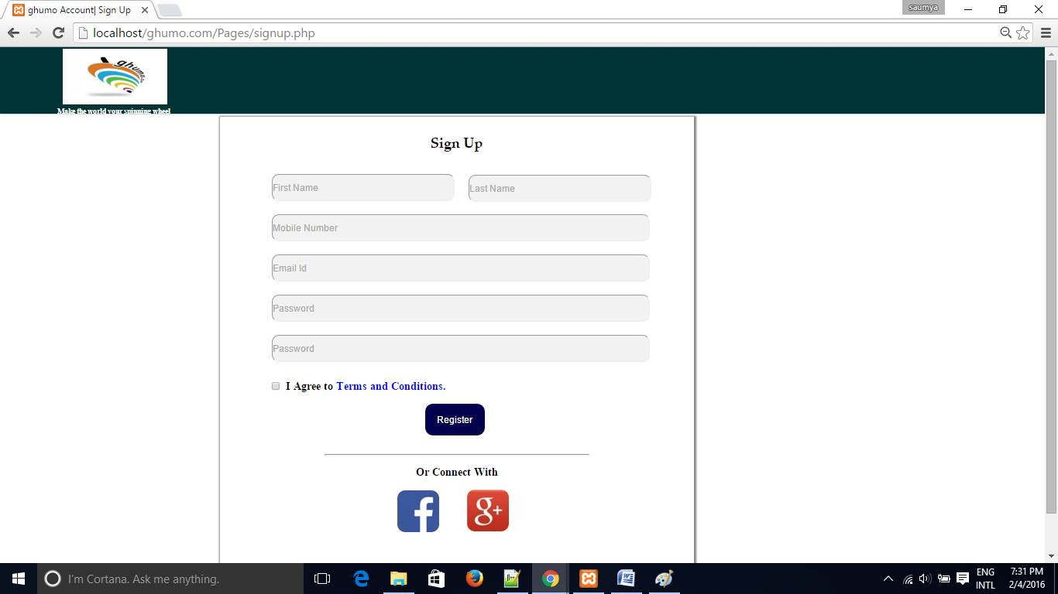

* Once the user has signed up, he can login to the site after verifying his/her email-id.

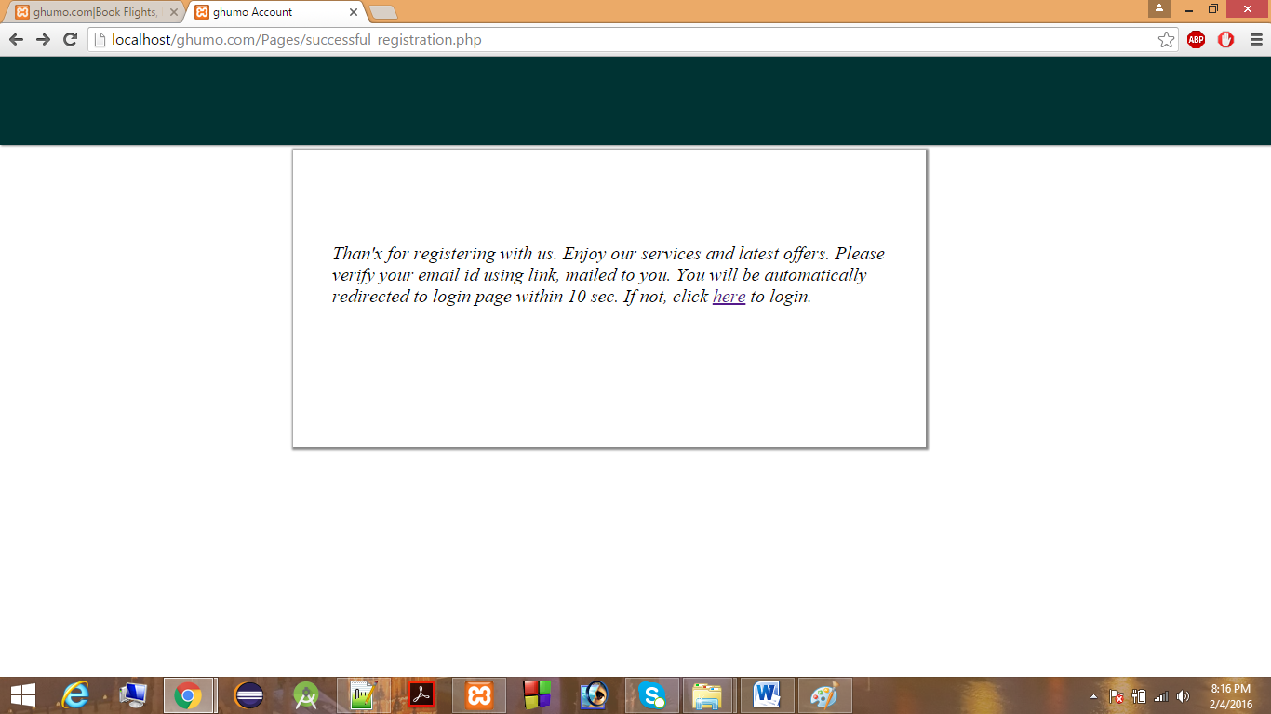

* After creating the account, you can login and have access to your ‘My Account’.

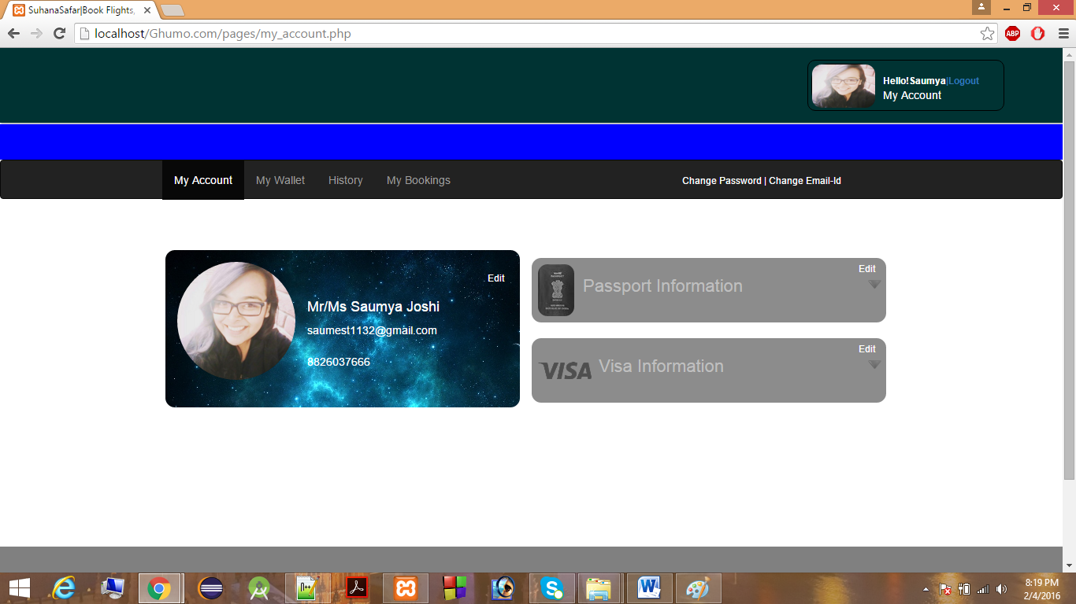

* Now you can add and update your personal information, visa and passport details.
* You now have access to your ‘My Wallet’ linked with our site.

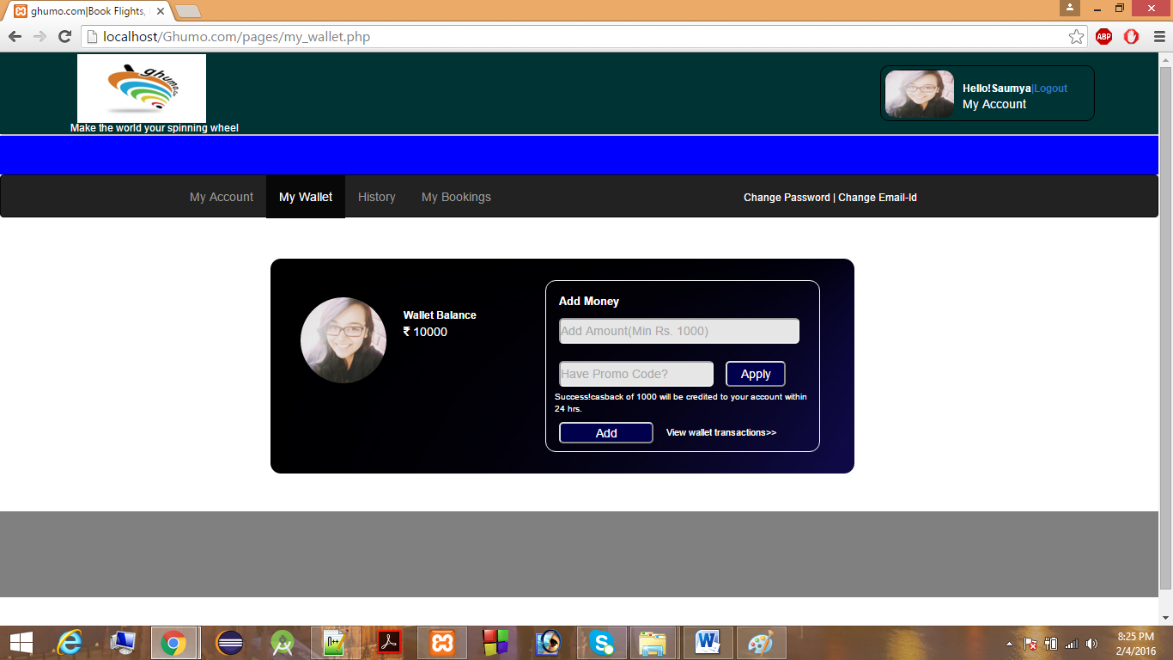

* To make hotel bookings, click on the hotel tab in the navigation bar. You will see this window.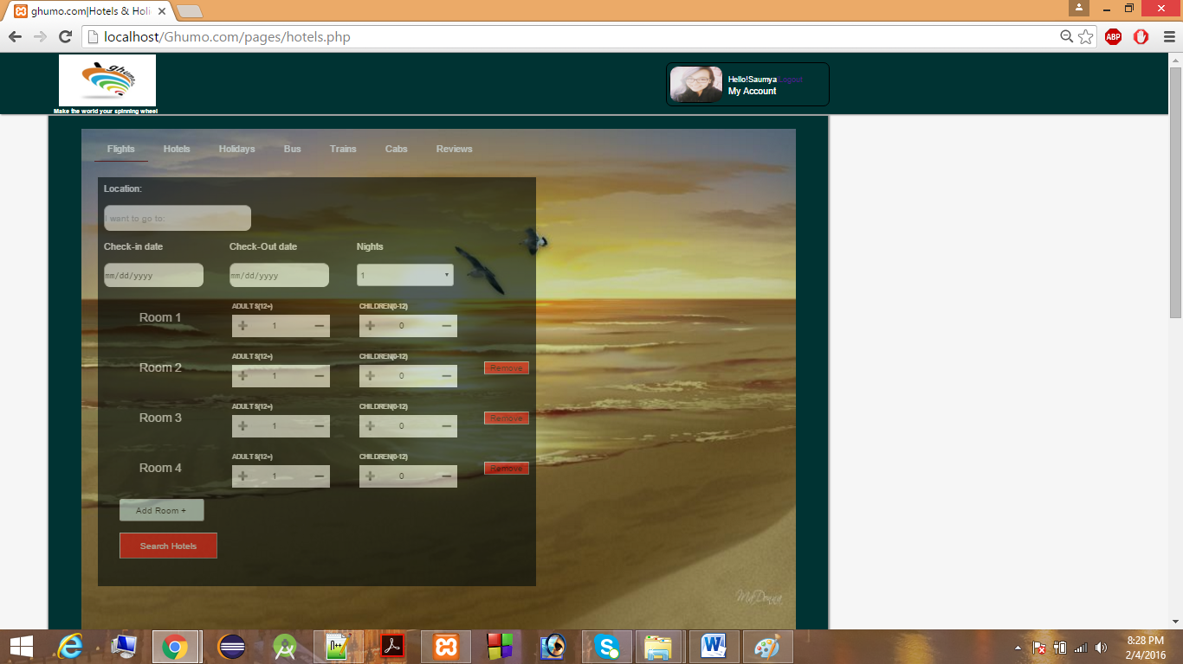
* We offer specially designed holiday packages to our customers so they do not have to make separate bookings for everything.

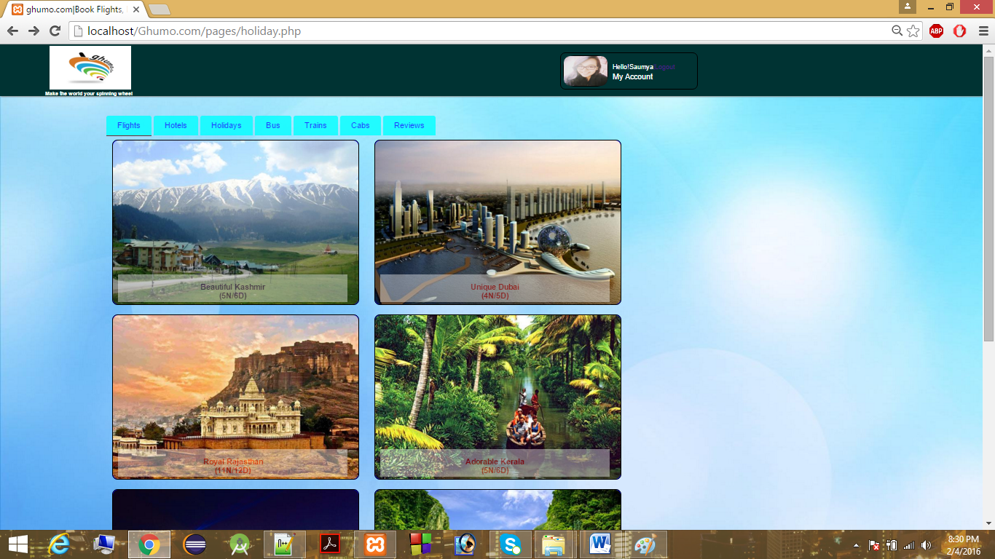

* We provide a special facility of booking a bus alongwith a hotel. These combo packages are easy to book and lighter on the pocket.

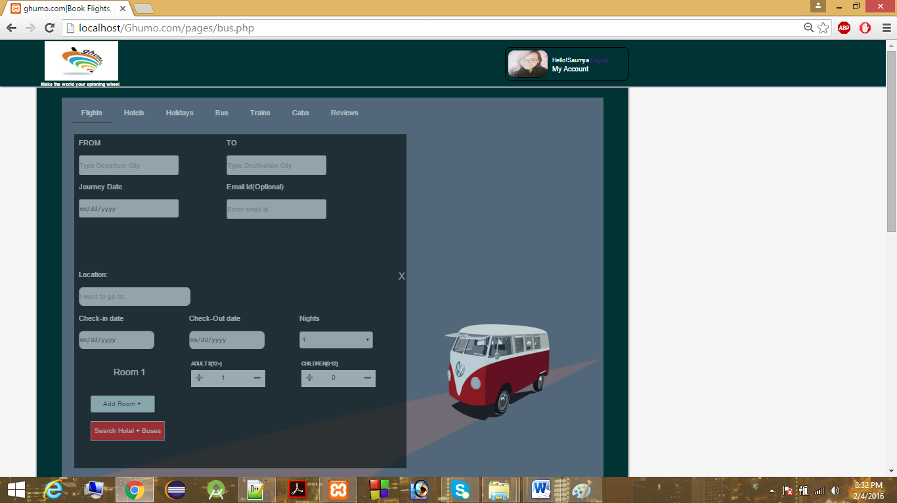

* Similarly, you can book cabs and trains and flights by clicking on the respective tabs in the navigation bar.
* For example, if you have to book a hotel, fill the required details and click on ‘Search Hotel’. You will see this page

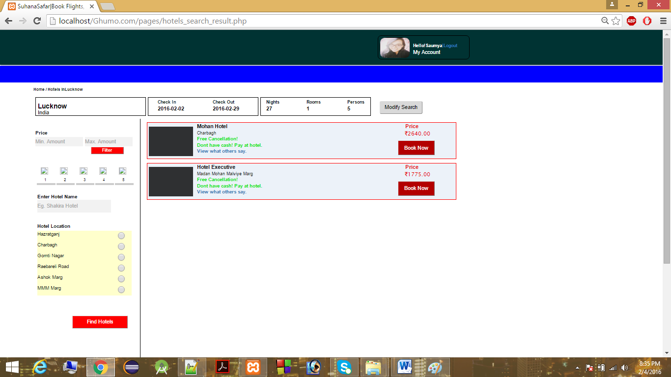

* You can filter your search result according to your convenience.
* After clicking on ‘Book Now’, you will see this page.

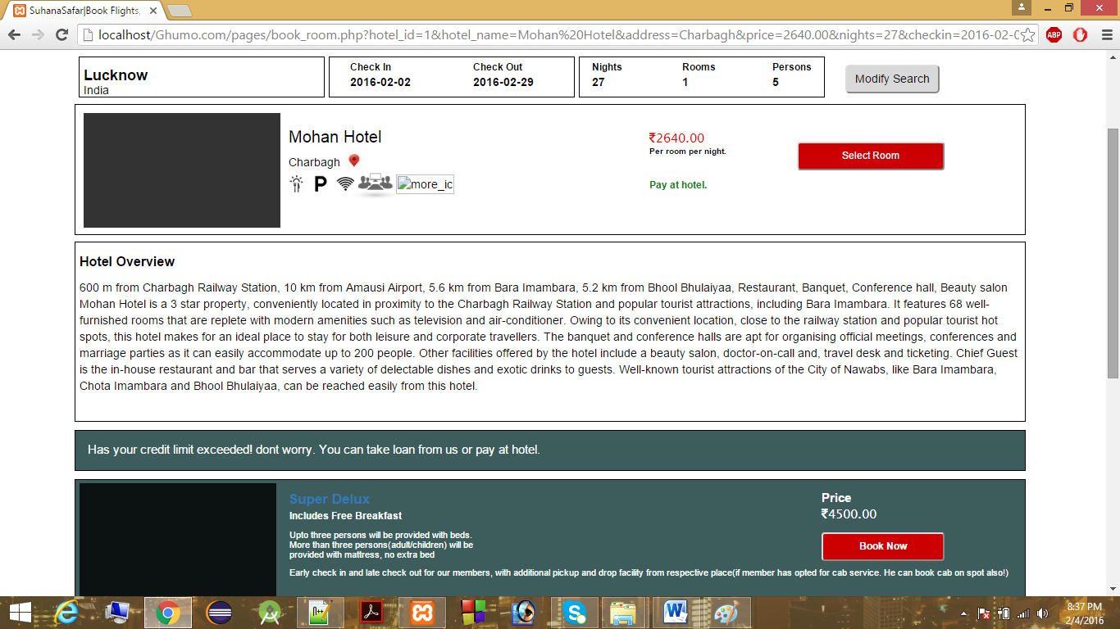

* You can modify your search by clicking on ‘Modify Search’ or you can book the room by clicking on ‘Book Now’.
* Once you click ‘Book Now’, the following page will be displayed.

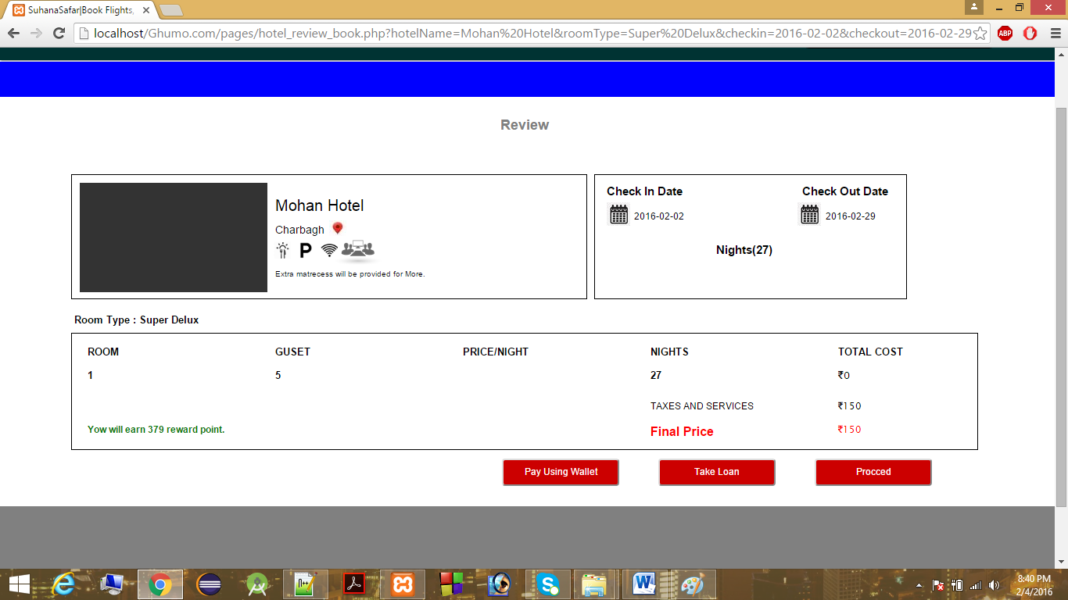

* You can choose payment option according to your convenience. If you click on ‘Proceed’, you will be redirected to payment page.

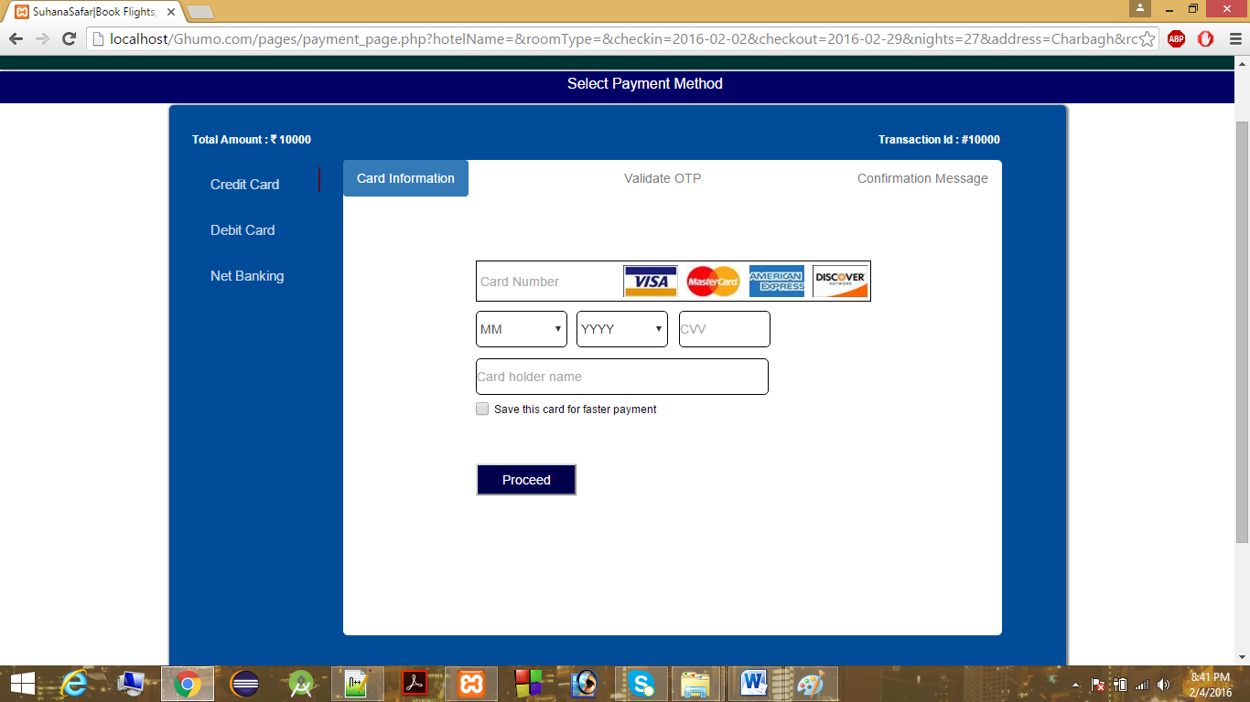

* You can choose payment options(Credit card, Debit card, Net banking) accordingly. Incase of Credit and Debit card, for validating registered user,we are sending OTP to the user’s registered email-id.
* Incase of net banking, we have a dummy database in which random user id and password is set. The user’s information is validated from the database and accordingly payment is proceeded.
* The database looks as follows:

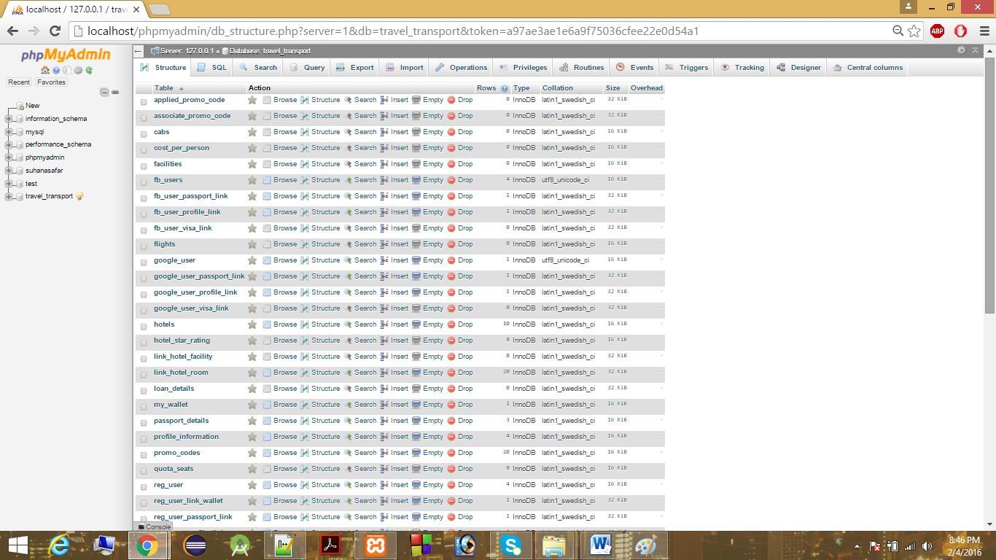

**RUNNING INSTRUCTIONS:**

* Get the Xampp server installed on your local machine(we have provided the folder with the setup).
* Paste the folder(ghumo.com) in php root directory(preferably C:\xampp\htdocs)
* We have provided the database tables as text files. Create the database accordingly.
* Now the site is ready for functioning. Enter the URL

[**http://localhost/ghumo.com/Pages/home.php**](http://localhost/ghumo.com/Pages/home.php)

and enjoy the site.

IMPROVISATIONS:

* The complete implementation is shown only for hotels. We have to extend it for all the available options.
* We are providing only the three payment methods. Some more payment methods such as e-wallets, My wallet etc have to be further worked upon.
* We have not provided the users the facility to create their own holiday packages. For now, we offer them specially designed holiday packages. This is being worked upon.
* This site is to be made more user friendly.
* The site is not so secure considering several security issues, so security is also one of the factor which need to be wored upon.

**Thank You.**